



Name : Hafsa Shahid
Reg no : B25F34CYS101
Program : Cybersecurity
Instructor’s name: Hassan Ali
Date Submitted : 10 / 07 / 26
Deadline : 10 / 07 / 26
Assignment Report # 4

\

• INTRODUCTION •
In this task we learned the capture and analysis of live network traffic using Wireshark, a open-source packet analyser. The main objective was to start a live capture then apply filters on them. We were given an assignment at the end; it goes as follows.

Assignments Tasks:

Task : Traffic Analysis, capture some Network traffic and apply some filters.
- Install and Run Wireshark.
- Start a live Capture and gather some Traffic.
- Explain and apply various filters on the traffic.

• TASK •
Task # 01 : Traffic Analysis, capture some Network traffic and apply some filters.
Steps Followed:
- Install and Run Wireshark.
- Start a live Capture and gather some Traffic.
- Explain and apply various filters on the traffic.

• STEP # 01 •
Step # 01 : Install and Run Wireshark.
- Install the Wireshark installer from its official website https://www.wireshark.org/download.html
- Continue with installation as normal.
- Following is what the main interface looks like.
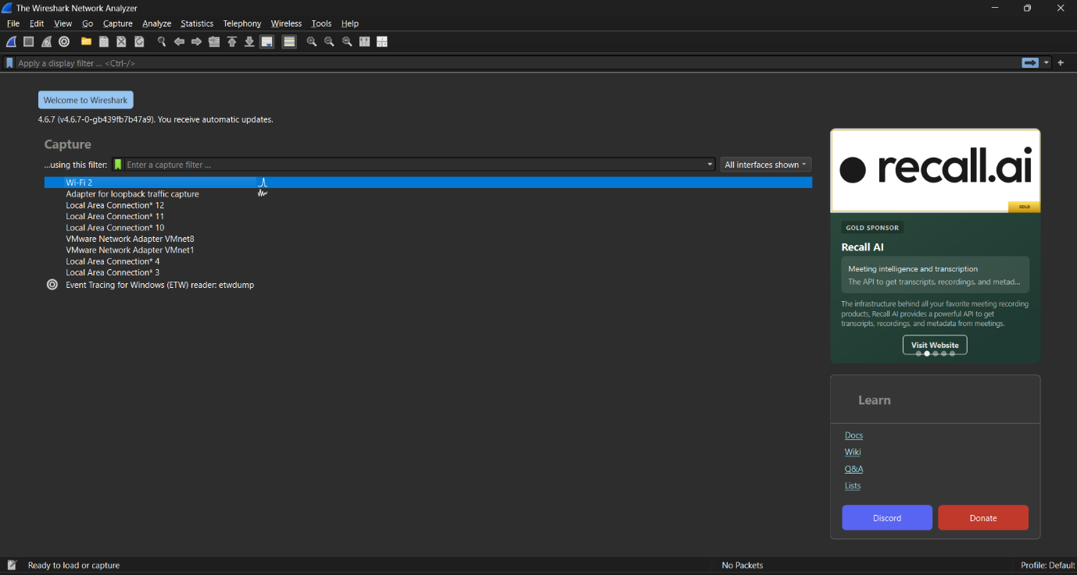
Step #01: Main Interface of Wireshark

• STEP # 02 •
Step # 02 : Start a live Capture and gather some Traffic.
- Click on the shark fin icon to start a live capture.
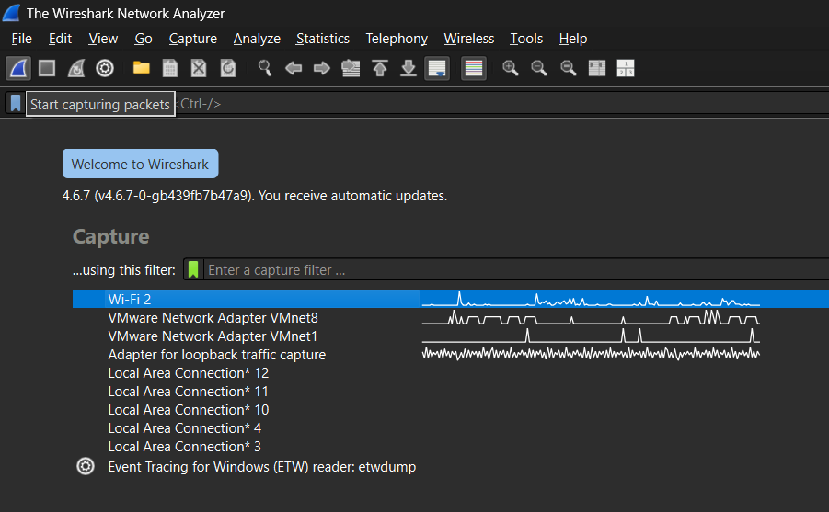

Step #02: Capturing Packets
This is what the capture looks like,
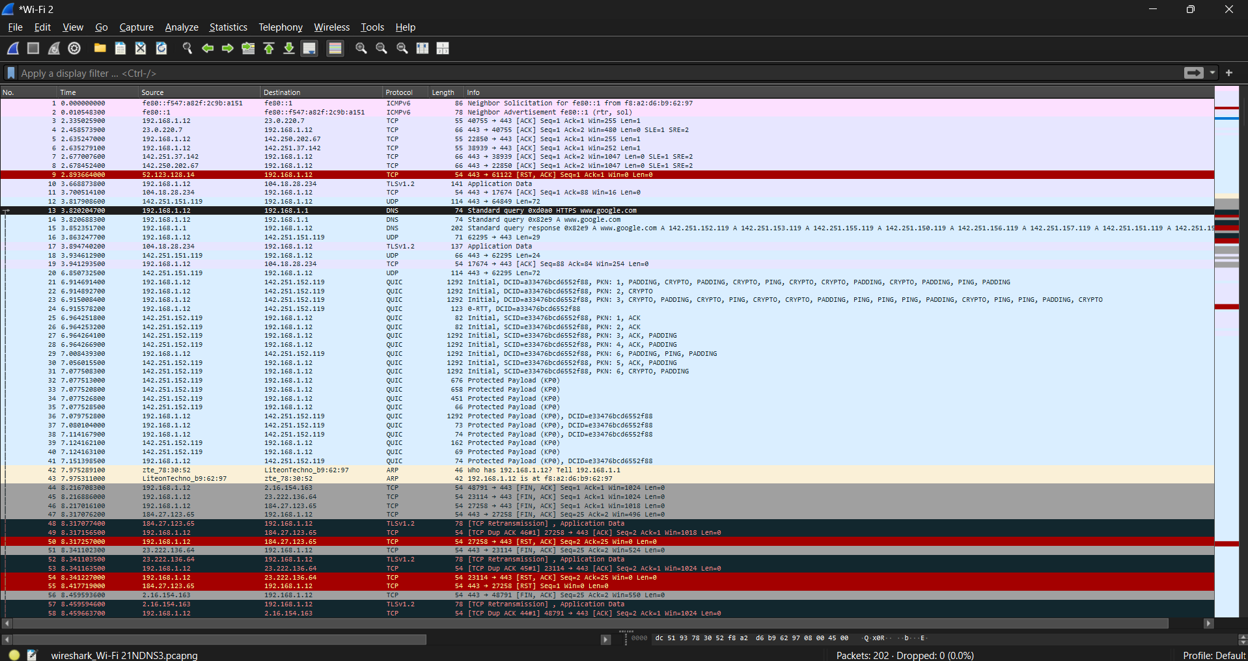

Step #02: Packets Captured
• STEP # 03 •
Step # 03 : Explain and apply various filters on the traffic.
- DNS Filter : Displays only DNS (Domain Name System) queries and responses. Useful for: Seeing domain name resolutions.

- HTTP Filter : Shows only HTTP traffic.
Useful for: Analysing plain web traffic and requests.

- tcp.port == 443 : Filters HTTPS traffic.
Useful for: Viewing secure web browsing traffic.

- TCP Filter : Shows all TCP packets.
Useful for: General analysis of reliable connections.

- ip.addr == 192.168.1.1 : Shows all packets whose destination or source is 192.168.1.1.

After Applying DNS Filter,
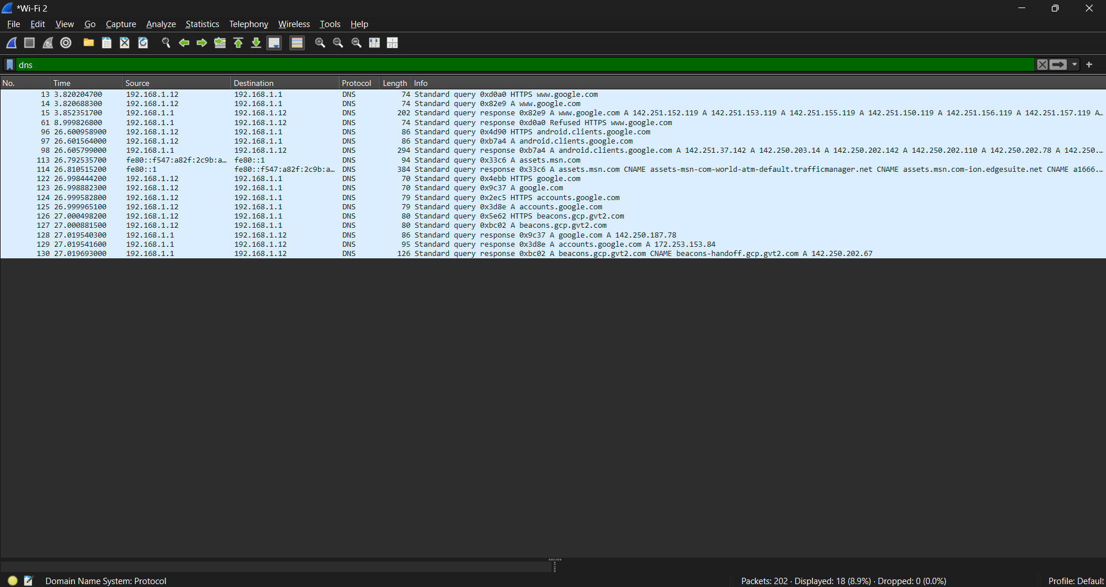

Step #03: DNS Filter
After Applying HTTP Filter, as we can see no http requests were recorded.
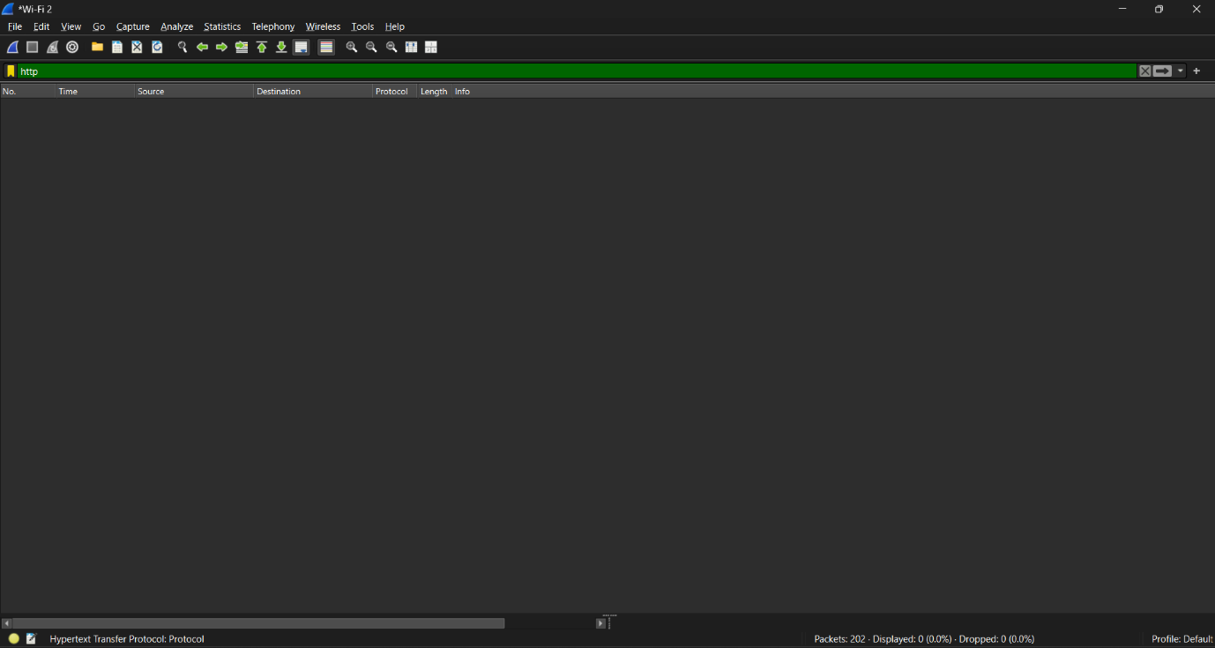

Step #03: HTTP Filter

After Applying tcp.port == 443 Filter,
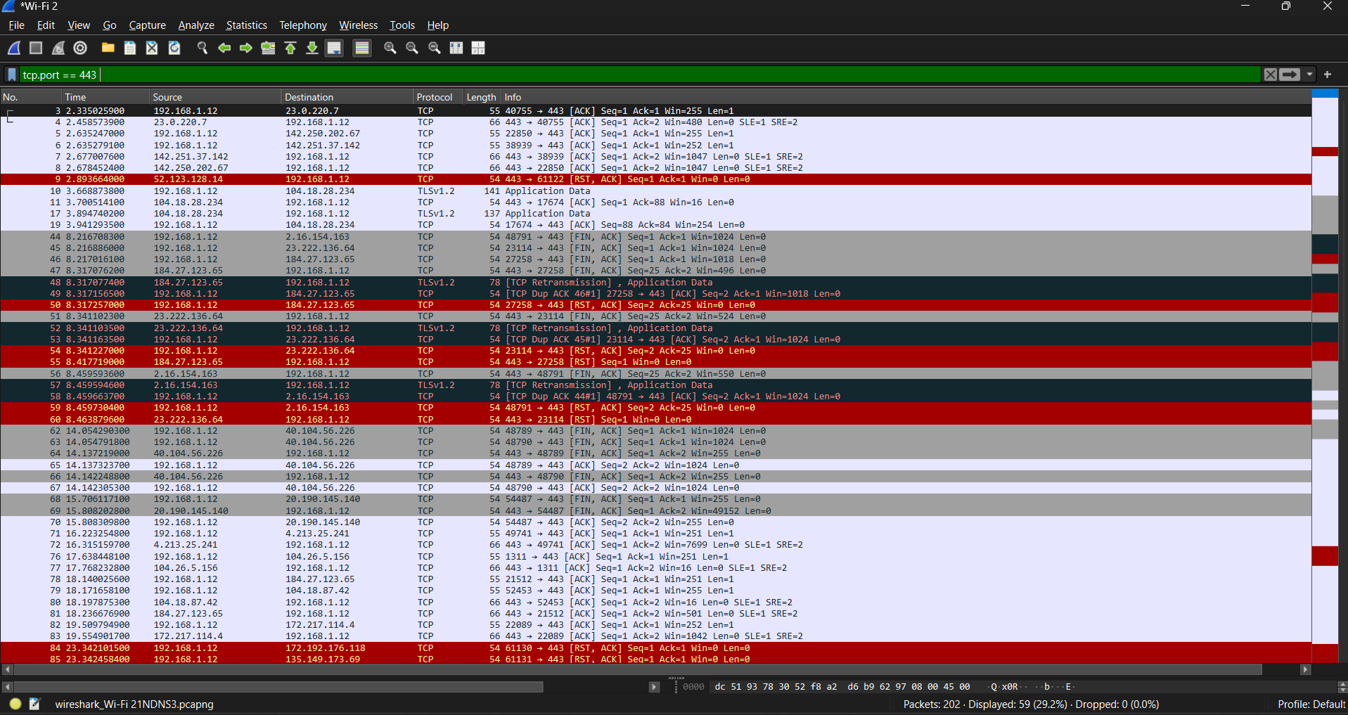

Step #03: tcp.port==443 Filter

After Applying TCP Filter,
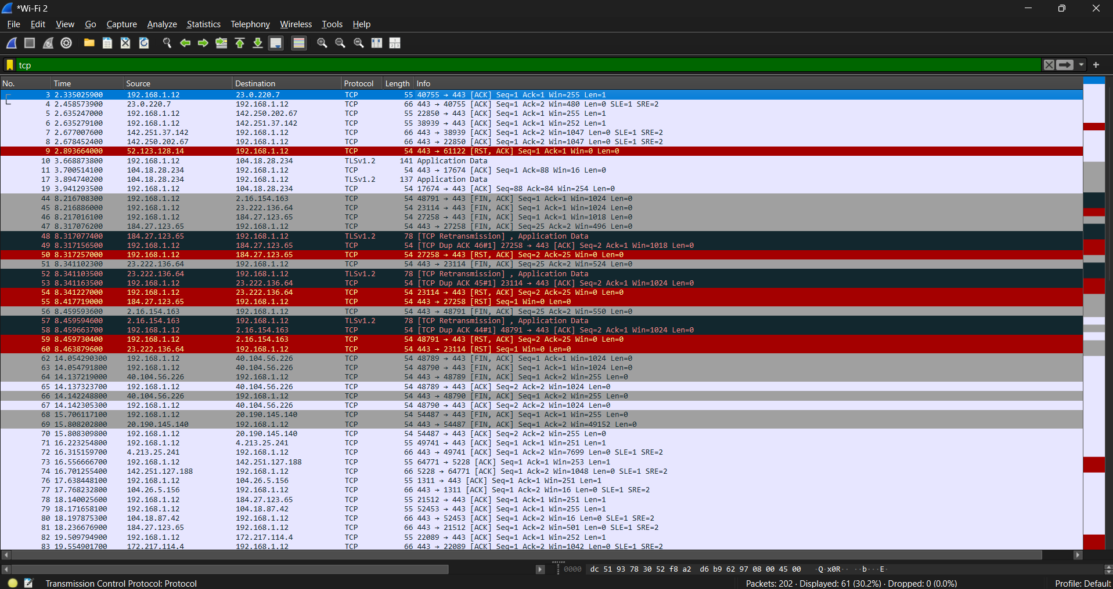
Step #03: TCP Filter

After Applying ip.addr == 192.168.1.1 Filter,
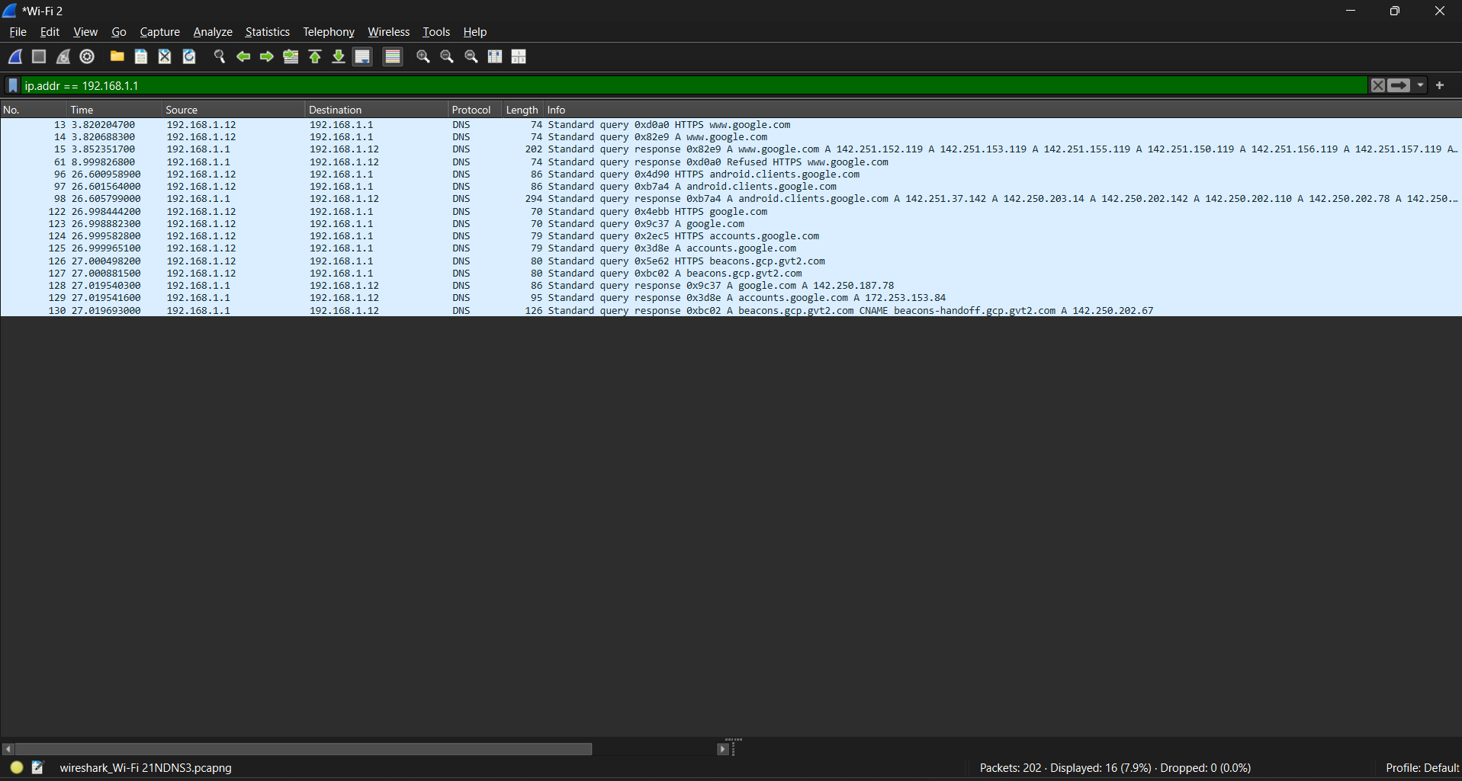
Step #03: ip.addr == 192.168.1.1 Filter

Assignment Conclusion:
In this assignment we ran some display filters over some Network Traffic in Wireshark to get a understanding of networking fundamentals. This increased and polished my ability to use and learn more about cybersecurity.

• The End •

